**StoreApp**

**Post a new Store –**

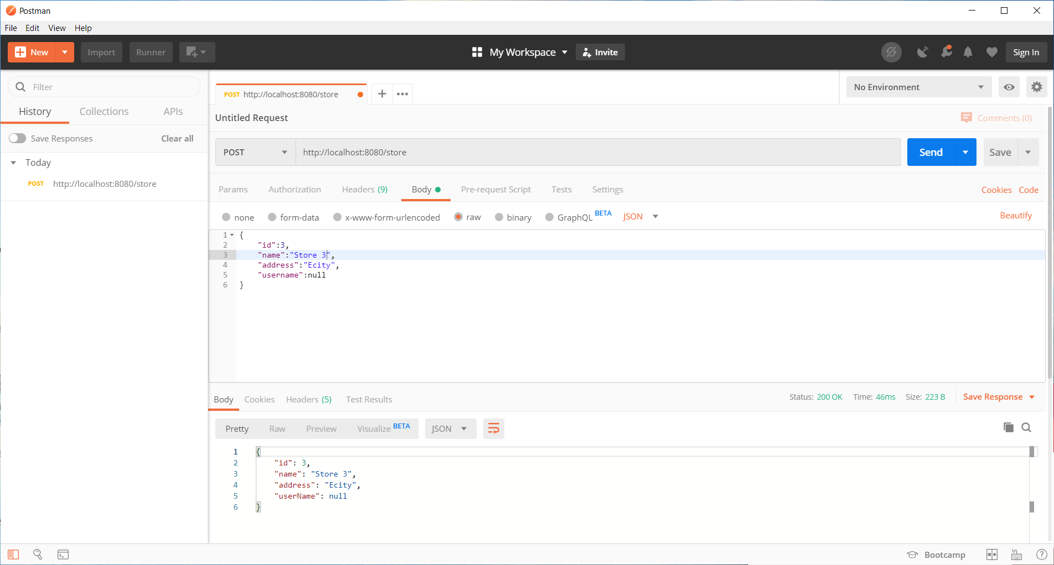

**Get Store by Id - http://localhost:8080/store/3**

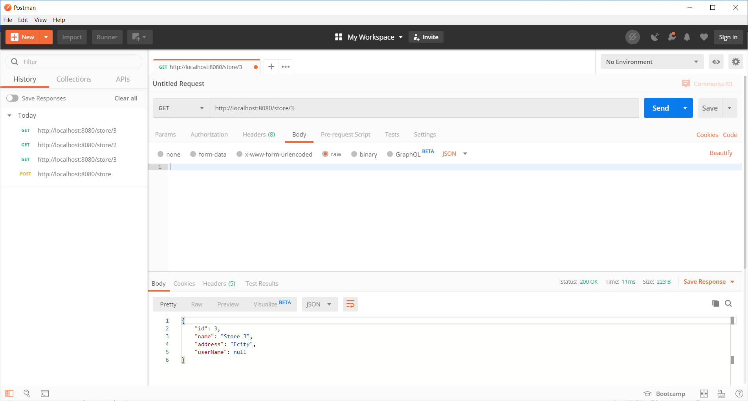

**Assigning Store 3 to the current User : User1**

**Put: http://localhost:8080/assignStore/3**

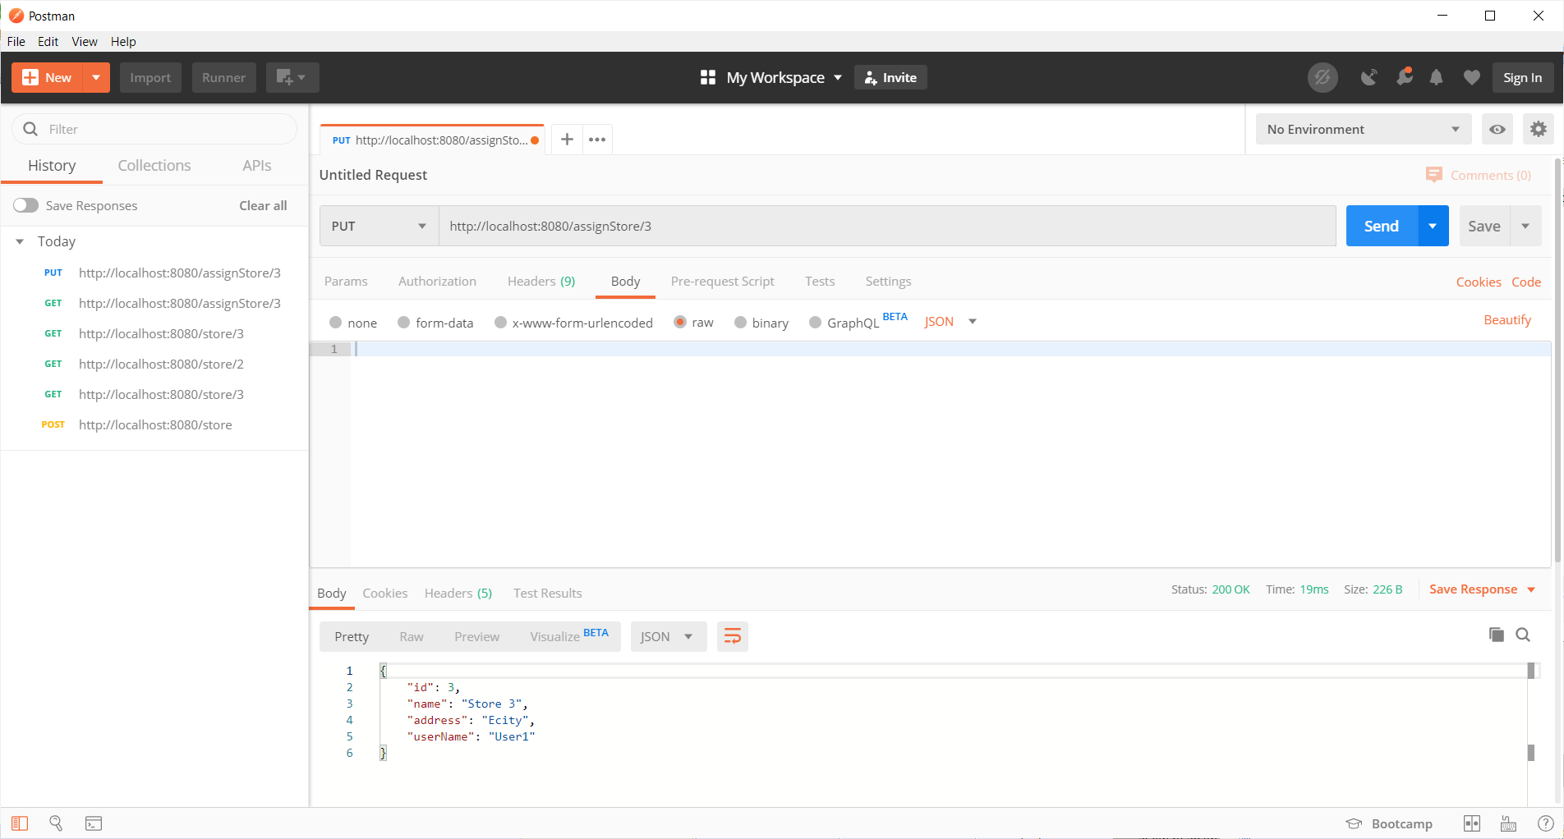

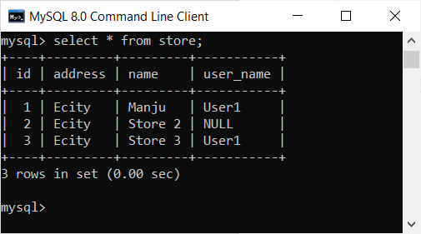

The End